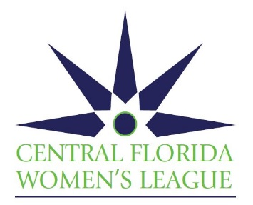
AUCTION ITEM DONATION FORM
We sincerely thank you for your support of the Central Florida Women’s League (CFWL) Power of the Purse Luncheon to be held on November 18, 2022 at Four Seasons Resort Orlando. For over 34 years, CFWL has always been an entirely volunteer organization dedicated to supporting worthy local charities, providing compassion funding and allocating scholarships to deserving high school seniors. Funds raised at this event will support the 2023 grant and scholarship recipients.
All auction donors will be recognized at the event with expected guest attendance of 300.
PLEASE FILL OUT THIS FORM COMPLETELY. FOR QUESTIONS OR TO HAVE YOUR ITEM PICKED UP PLEASE CONTACT– Lynn Rooks 317-519-0035 lynna_rooks@hotmail.com
ALL SERVICES, TICKETS, GIFT CARDS, ETC. SHOULD BE VALID FOR 1 (ONE) CALENDAR YEAR FROM THE EVENT DATE OF November 18, 2022
Donor and/or Company Name: __________________________________________________________ Contact Name: ______________________________________________________________________ Mailing Address: _____________________________________________________________________ ___________________________________________________________________________________ Phone: ____________________________________________________________________________ Email: ______________________________________________________________________________
Description of Donated Item(s) - Please describe fully, (i.e., name of item, specific instructions, size, color, dates available, locations, etc. Please attach brochure or other relevant marketing materials, if possible.): ____________________________________________________________________________________
Value of Donation $ :__________________________________________________________________
Delivery or pick-up date: (no later than 10/15/22):___________________________________________
Donor/Representative’s Signature: _______________________________________________________
Please make a copy of this form for your records before returning. Formal acknowledgement to follow. Central Florida Women’s League is a 501(c)(3) not-for-profit corporation. FEIN NO: 59-6314854
Auction Item Solicitor’s Name and Phone Number:__________________________________________ Date Form Received:________________________ Date Item Received:___________________________
The following information is provided as required by the 1991 Florida “Solicitation of Contributions Act” A copy of the official registration (CH-28734) and financial information may be obtained from the division of consumer services by calling toll free within the USA 800-435-7352d. Registration does not imply endorsement, approval or recommendation by the State.

